Authors’ Instructions for the Preparation
Gil Dong Hong , Ji Su Park *

Dept. of Computer Science and Engineering, Jeonju University

gdhong@gmail.comr, jisupark7203@gmail.com

Abstract. The abstract should summarize the contents of the paper and should contain at least 70 and at most 150 words. It should be set in 9-point font size and should be inset 1.0 cm from the right and left margins. There should be two blank (10-point) lines before and after the abstract. This document is in the required format.
Keywords: We would like to encourage you to list your keywords in this section.

1 Introduction
The Contact Volume Editor uses these details to compile a list for our production department at SPS in India. Once the files have been worked upon, SPS sends a copy of the final pdf of each paper to its contact author. The contact author is asked to check through the final pdf to make sure that no errors have crept in during the transfer or preparation of the files. This should not be seen as an opportunity to update or copyedit the papers, which is not possible due to time constraints. Only errors introduced during the preparation of the files will be corrected.
This round of checking takes place about two weeks after the files have been sent to the Editorial by the Contact Volume Editor, i.e., roughly seven weeks before the start of the conference for conference proceedings, or seven weeks before the volume leaves the printer’s, for post-proceedings. If SPS does not receive a reply from a particular contact author, within the timeframe given, then it is presumed that the author has found no errors in the paper. The tight publication schedule of LNCS does not allow SPS to send reminders or search for alternative email addresses on the Internet.
In some cases, it is the Contact Volume Editor that checks all the pdfs. In such cases, the authors are not involved in the checking phase.

Acknowledgment must be written at the bottom of the first page.
1.1 Additional Information Required by the Volume Editor
If you have more than one surname, please make sure that the Volume Editor knows how you are to be listed in the author index.
1.2 Copyright Forms
The copyright form may be downloaded from the For Authors section of the LNCS Webpage: www.springer.com/lncs. Please send your signed copyright form to the Contact Volume Editor, either as a scanned pdf or by fax or by courier. One author may sign on behalf of all of the other authors of a particular paper. Digital signatures are acceptable.
2 Paper Preparation
The printing area is 122 mm × 193 mm. The text should be justified to occupy the full line width, so that the right margin is not ragged, with words hyphenated as appropriate. Please fill pages so that the length of the text is no less than 180 mm, if possible.
Use 10-point type for the name(s) of the author(s) and 9-point type for the address(es) and the abstract. For the main text, please use 10-point type and single-line spacing. We recommend the use of Computer Modern Roman or Times. Italic type may be used to emphasize words in running text. Bold type and underlining should be avoided.
Papers not complying with the LNCS style will be reformatted. This can lead to an increase in the overall number of pages. We would therefore urge you not to squash your paper.
Table 1. Font sizes of headings. Table captions should always be positioned above the tables.
Heading level | Example | Font size and style
Title (centered) | Lecture Notes … | 14 point, bold
1st-level heading | 1 Introduction | 12 point, bold
2nd-level heading | 2.1 Printing Area | 10 point, bold
3rd-level heading | Headings. Text follows … | 10 point, bold
4th-level heading | Remark. Text follows … | 10 point, italic
Lemmas, Propositions, and Theorems. The numbers accorded to lemmas, propositions, and theorems, etc. should appear in consecutive order, starting with Lemma 1, and not, for example, with Lemma 11.
2.1 Figures
Remark 1. In the printed volumes, illustrations are generally black and white (halftones), and only in exceptional cases, and if the author is prepared to cover the extra costs involved, are colored pictures accepted. Colored pictures are welcome in the electronic version free of charge. If you send colored figures that are to be printed in black and white, please make sure that they really are legible in black and white. Some colors show up very poorly when printed in black and white.

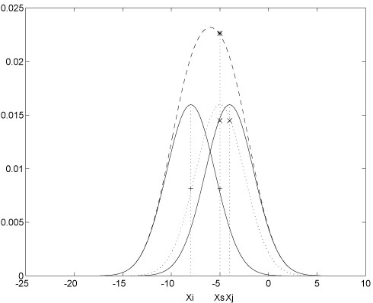
Fig. 1. One kernel at xs (dotted kernel) or two kernels at xi and xj (left and right) lead to the same summed estimate at xs. This shows a figure consisting of different types of lines. Elements of the figure described in the caption should be set in italics, in parentheses, as shown in this sample caption.
2.2 Formulas
Displayed equations or formulas are centered and set on a separate line (with an extra line or halfline space above and below). Displayed expressions should be numbered for reference. The numbers should be consecutive within each section or within the contribution, with numbers enclosed in parentheses and set on the right margin.
x + y = z . | (1)
References
1. Smith, T.F., Waterman, M.S.: Identification of Common Molecular Subsequences. J. Mol. Biol. 147, 195--197 (1981)
2. May, P., Ehrlich, H.C., Steinke, T.: ZIB Structure Prediction Pipeline: Composing a Complex Biological Workflow through Web Services. In: Nagel, W.E., Walter, W.V., Lehner, W. (eds.) Euro-Par 2006. LNCS, vol. 4128, pp. 1148--1158. Springer, Heidelberg (2006)
3. Foster, I., Kesselman, C.: The Grid: Blueprint for a New Computing Infrastructure. Morgan Kaufmann, San Francisco (1999)
4. Czajkowski, K., Fitzgerald, S., Foster, I., Kesselman, C.: Grid Information Services for Distributed Resource Sharing. In: 10th IEEE International Symposium on High Performance Distributed Computing, pp. 181--184. IEEE Press, New York (2001)
5. Foster, I., Kesselman, C., Nick, J., Tuecke, S.: The Physiology of the Grid: an Open Grid Services Architecture for Distributed Systems Integration. Technical report, Global Grid Forum (2002)
6. National Center for Biotechnology Information, http://www.ncbi.nlm.nih.gov

* Corresponding Author: Ji Su Park (jisupark7203@gmail.com) **Acknowledgement: This work was supported under the Bio/medical technology development project managed by National Research Foundation of Korea

